

Developing Software: Introduction
(H173 34)

How to use the Turbo C++ compiler within Windows 7

Copy the “S:\hccomp\Dean\Block1\ IDE” folder
onto the root directory of your travelling disk (or H:\ drive)

Launch the DOSBox application copied to your travelling disk

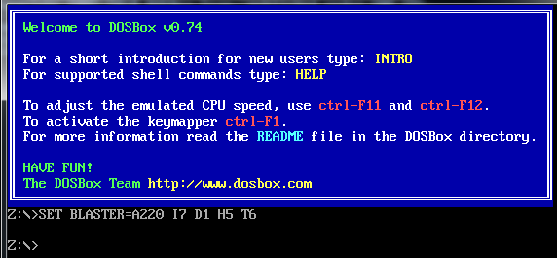

Type in the following command at the Z:\> prompt provided -
mount c: e:\ide
(Note that e: above is the drive letter for your travelling disk)

At the Z:\> prompt type C: then enter
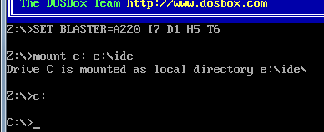

At the C:\> prompt provided, type KEYB uk then enter

Then type TC\BIN\TC to launch the Borland Turbo C++ Version 3.0 compiler

To toggle to full screen mode, use ALT-ENTER

Save (and organise) your source code within the C:\C_SOURCE folder

When you Quit (ALT+X) Turbo C++ type exit at the C:\> prompt to close DOSBox

